Sri Lanka Institute of Information Technology



Lab Submission

Lab Sheet 08

**IT24103989 Gunarathna H.M.S.S**

**Probability and Statistics| IT2120**

B.Sc. (Hons) in Information Technology

**Question 01:**

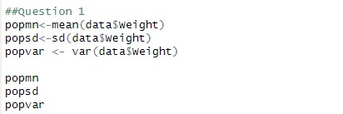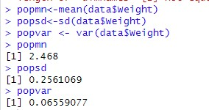

**Question 02:**

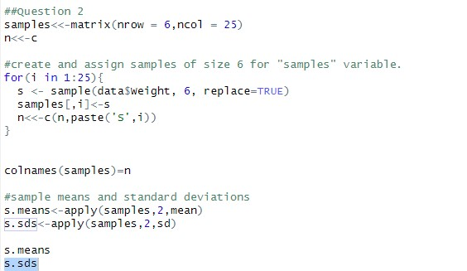

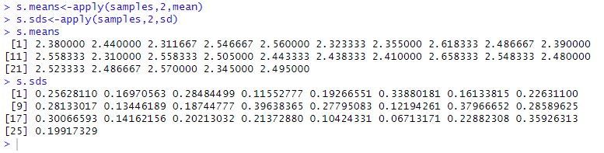

**Question 03:**

